1.创建视图

CREATE VIEW v_members AS

SELECT * FROM members

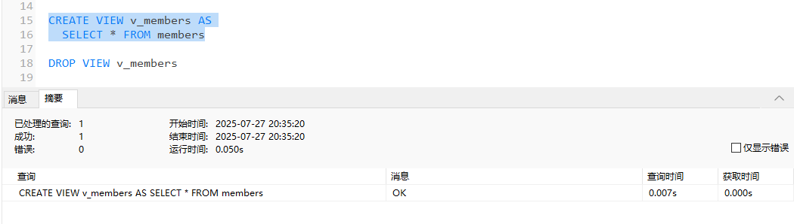

2.删除视图

DROP VIEW v_members

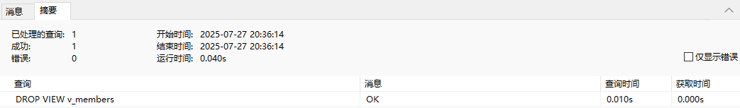

3.创建一个带参数的存储过程

CREATE PROCEDURE pro_insert(

IN uname VARCHAR(50),

IN email VARCHAR(50))

BEGIN

INSERT INTO members(member_id,member_name,member_email,password)

VALUES(NULL,uname,email,'123');

SELECT * FROM members ORDER BY member_id DESC;

END

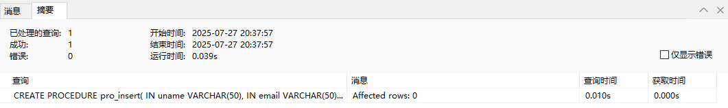

4.调用存储过程

CALL pro_insert('fwfff','ffwff')

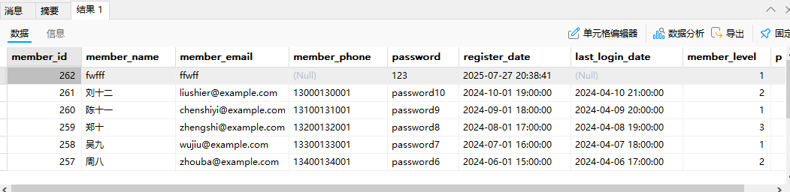

5. 创建存储过程，WHILE循环

CREATE PROCEDURE pro_insert_10(

IN uname VARCHAR(50),

IN email VARCHAR(50))

BEGIN

DECLARE num INT DEFAULT 10;

DECLARE i INT DEFAULT 0;

WHILE i<num DO

INSERT INTO members(member_id,member_name,member_email,password)

VALUES(NULL,CONCAT(uname,i),CONCAT(email,i),'123');

SET i = i+1;

END WHILE;

SELECT * FROM members WHERE 1;

END

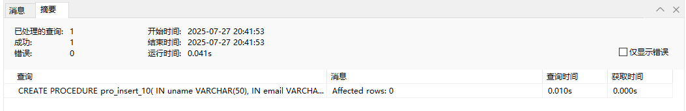

6.调用存储过程，WHILE循环

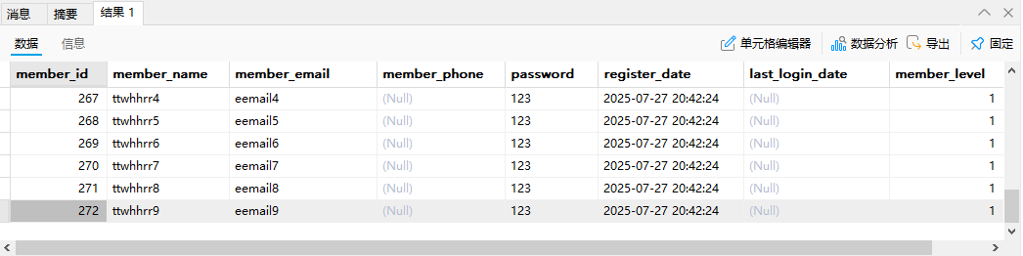

7.触发器创建

CREATE TRIGGER tr_updata

AFTER

INSERT ON orders

FOR EACH ROW

BEGIN

DECLARE pro_num INT;

DECLARE pro_unit_price INT;

SELECT product_id,price INTO pro_num,pro_unit_price FROM products WHERE product_id =3;

INSERT INTO order_items(order_id,product_id,quantity,unit_price)

VALUES (new.order_id,pro_num, pro_unit_price*pro_num , pro_unit_price);

UPDATE products SET stock = stock - 1;

END

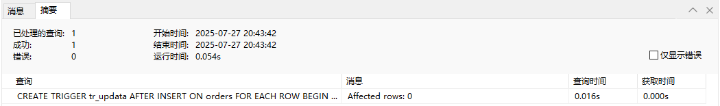

8.触发上面触发器

INSERT INTO orders(order_id,member_id,total_amount,order_status)

VALUES(NULL,'11',1500,'未支付');

9.查看是否触发

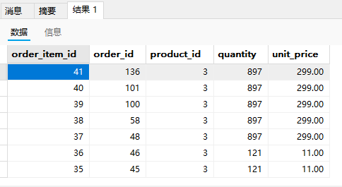

10.触发器中的NEW，OLD关键字

CREATE TRIGGER tr_update_order

AFTER UPDATE ON orders

FOR EACH ROW

BEGIN

IF OLD.order_status='未支付' ANDNEW.order_status='已支付' THEN

UPDATE products join order_items join orders

ON orders.order_id=order_items.order_id and products.product_id=order_items.product_id

SET stock = stock - quantity

WHERE orders.order_id= NEW.order_id;

END IF;

END;

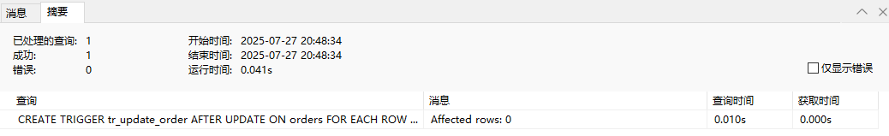

11.触发器的三种触发方式

-- UPDATE 触发器

CREATE TRIGGER tr_update_order

AFTER UPDATE ON orders

FOR EACH ROW

BEGIN

END;

-- INSERT 触发器

CREATE TRIGGER tr_insert_order

AFTER INSERT ON orders

FOR EACH ROW

BEGIN

END;

-- DELETE 触发器

CREATE TRIGGER tr_delete_order

AFTER DELETE ON orders

FOR EACH ROW

BEGIN

END;

12. 新增订单，会员积分增加

CREATE TRIGGER tr_insert_orders

AFTER INSERT ON orders

FOR EACH ROW

BEGIN

UPDATE products join order_items join orders

ON orders.order_id=order_items.order_id and products.product_id=order_items.product_id

SET stock = stock - quantity

WHERE orders.order_id = NEW.order_id;

UPDATE members

SET points= points + 10

WHERE member_id= New.member_id;

END;

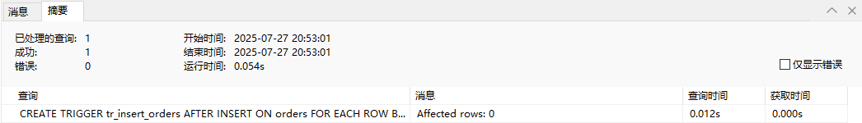

13.触发上面触发器

INSERT INTo orders(order_id,member_id,total_amount,order_status,shipping_address,payment_method)

VALUES(NULL,1,'100','未支付','四川','微信支付');

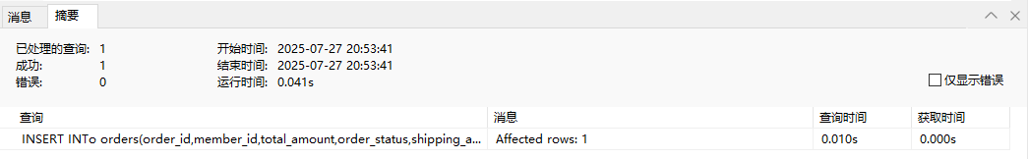

14.查看触发结果

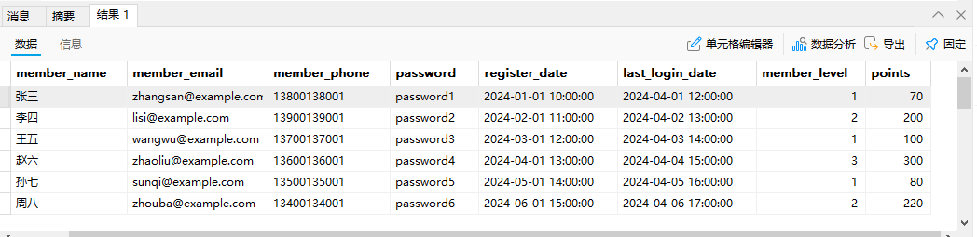

15.事务

事务TRANSACTION：若干个增删改查 操作集合；

16.事务特性

ACID: 原子性 一致性 隔离性 持久性

17.事务的开启

START TRANSACTION;

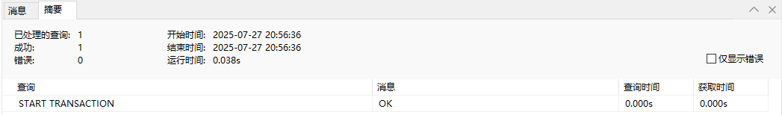

18.开启事务后进行操作并查询结果

INSERT INTo orders(order_id,member_id,total_amount,order_status,shipping_address,payment_method)

VALUES(NULL,1,'100','未支付','四川222','微信支付222');

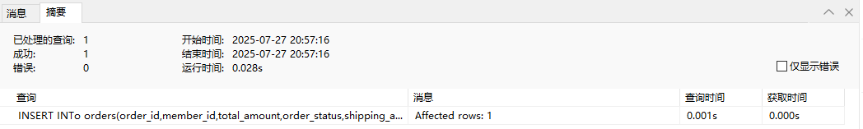

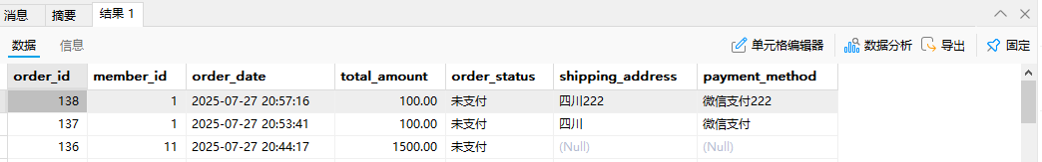

18.事务回滚后并查看

ROLLBACK; -- 回滚事务

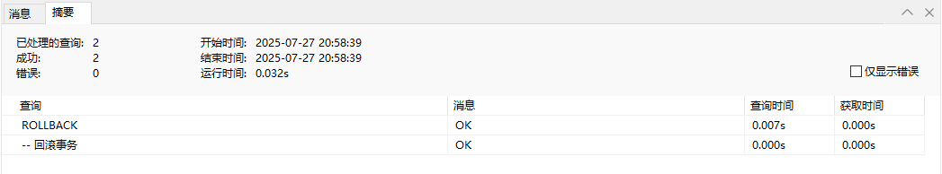

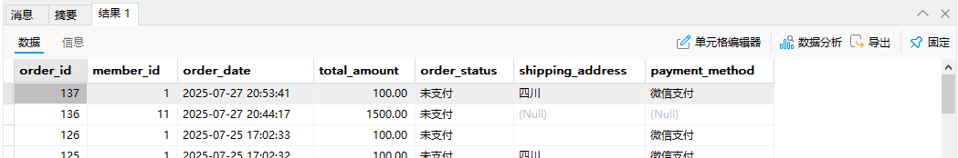

19.提交事务

COMMIT; -- 提交

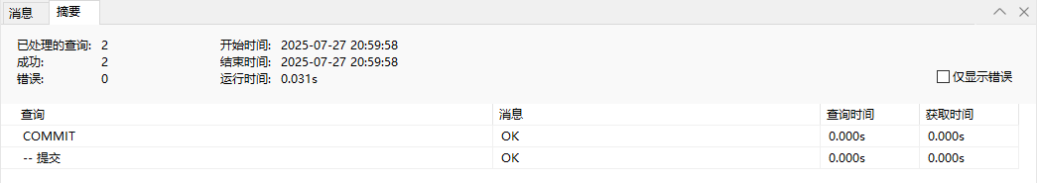

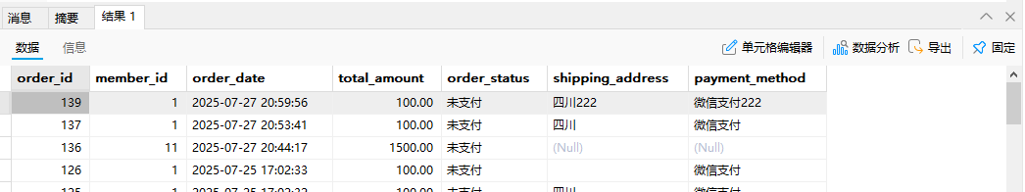

20.事务的另一种开启方式

BEGIN;

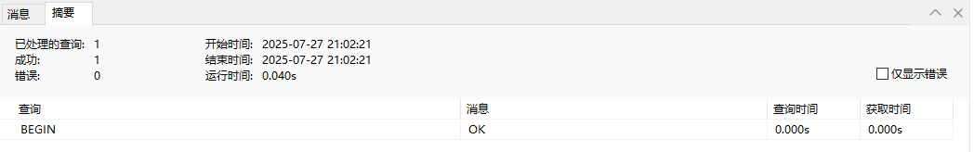

21.BEGIN方式插入数据并提交

INSERT INTO orders(order_id,member_id,total_amount,order_status,shipping_address,payment_method)

VALUES(NULL,'2',100,'未支付','四川成都','微信支付');

COMMIT ;





SELECT * FROM orders ORDER BY order_id DESC;

